AI ASSISSTED CODING LAB-7.3
Name:v.praneeth
Rollno:2303A52146
batch:41
Task 1: Fixing Syntax Errors
Scenario
You are reviewing a Python program where a basic function definition contains a syntax error.
Code with syntax error
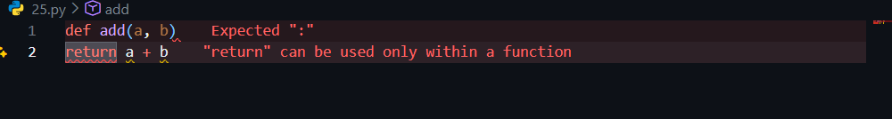
Error Identified by AI
- Type of Error: SyntaxError
- Reason: Python requires a colon (:) at the end of a function definition line.

Code debugged by ai
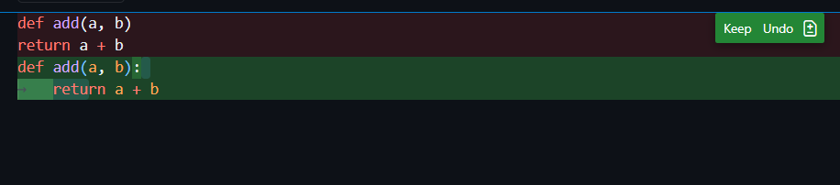
Output:
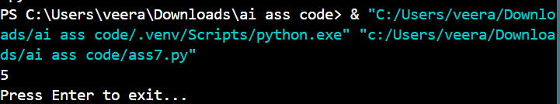
Explanation by AI
The AI detected a syntax error because the function declaration line did not end with a colon. In Python, the colon indicates the start of an indented code block. Without it, the interpreter cannot parse the function body.
• AI-generated explanation of the fix
Task 2: Debugging Logic Errors in Loops
Scenario
You are debugging a loop that runs infinitely due to a logical mistake.
Requirements
Code with erros
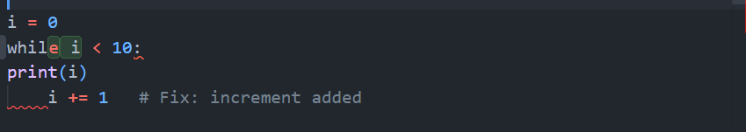
Error Identified by AI
Type of Error: Logical Error
Reason: The loop variable is decremented instead of incremented, so the condition i <= 5 is always true.
Code debugged by ai
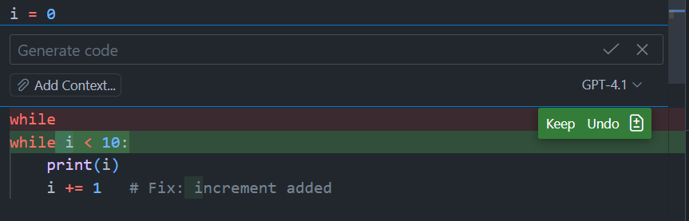
Output:
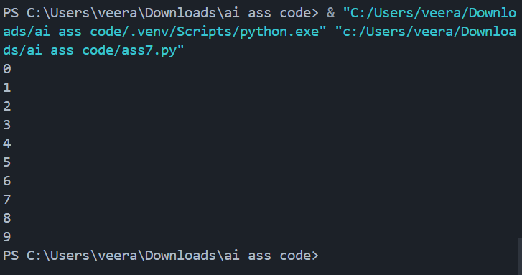
Explanation by AI
The loop condition depends on i increasing toward a stopping point. Decrementing i causes it to move away from the termination condition, resulting in an infinite loop.
Task 3: Handling Runtime Errors (Division by Zero)
Scenario
A function crashes due to division by zero.
Buggy code
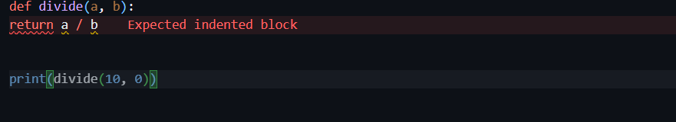
Error Identified by AI
- Type of Error: Runtime Error (ZeroDivisionError)
- Reason: Division by zero is mathematically undefined.
Debugged code
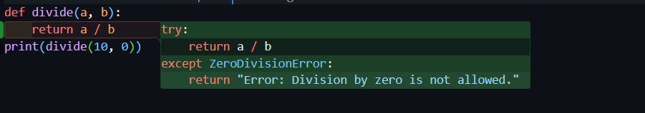
Output:
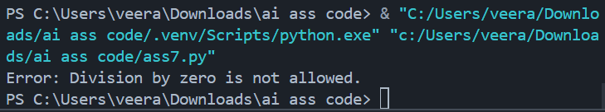
Explanation by AI
The AI added exception handling using try-except to prevent program termination. This ensures graceful handling of invalid input instead of crashing the program.
Task 4: Debugging Class Definition Errors
Scenario
A Python class constructor is incorrectly defined without the self parameter.
Buggy Code
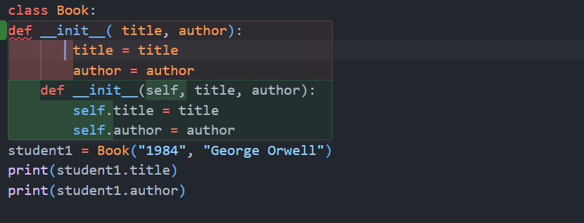
Error Identified by AI
- Type of Error: TypeError / Object-Oriented Error
- Reason: The self parameter is mandatory for instance variable access.
Debugged code

Output:
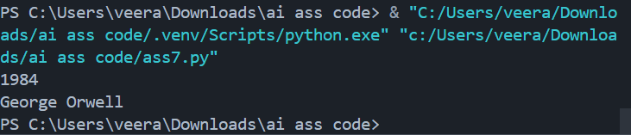
Explanation by AI
The self parameter represents the current object instance. Without it, instance variables cannot be properly assigned or accessed.
Task 5: Resolving Index Errors in Lists
Scenario
A program crashes when accessing an invalid list index.
Buggy Code
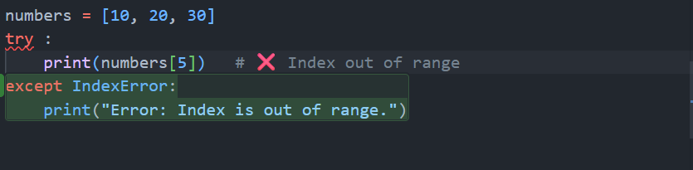

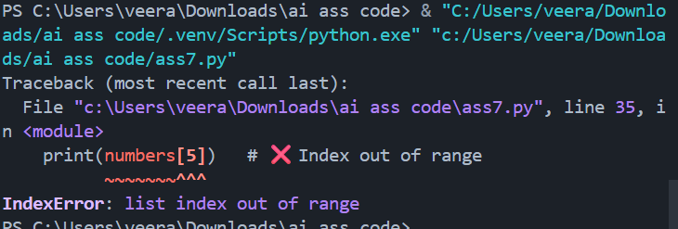
Error Identified by AI
- Type of Error: IndexError
- Reason: Index is outside the valid range of the list.
Debugged code

Explanation by AI
The AI suggested two safe approaches: checking the index against list length or handling the exception using try-except. Both prevent program crashes.

